**Department of Computer Engineering**

**TE Computer-A (2021-22 Sem I)**

**Computer Networks and Security Lab**

**Practical Assignment 1 [Max Marks: 10]**

**Instructions:**

**1.** Write down step by step configuration with screen shots and upload document in pdf format on Microsoft team before due date. Also upload .pkt files (Packet tracer file) (File name Eg; Roll_Assg1.pdf and RollNo_Ans1.pkt, RollNo_Ans2.pkt and so on…).

2. IP Address Series you will use in Assignment according to your Roll Numbers (192.168.Roll_No.1 to 192.168.Roll_No.254 Example: Roll No 20 will use 192.168.20.1 to 192.168.20.254)

**Assignment Questions:**

**Q1. LAN Setup in Cisco Packet Tracer** **[10 marks]**

**A. Connect two PC using Crossover Cable**

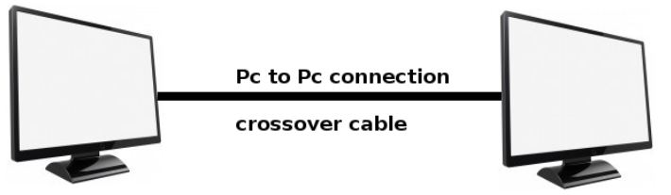

Ans: (Sample)

1. Network Topology (Screen Shot)
2. IP Address Configuration of PCs (Configuration Steps & Screen Shots)
3. Use ping utility to check availability of end systems/host
4. Real Mode Simulation (Screen Shots)

**ANS**

IP Address configuration screen -

●In 1st case connect all the computers with each other through ethernet cable . ● -Select pc1 go to -> desktop ->Ip configuration, -In ipv4 address put 192.168.23.1 , 59 being my roll no. Do same for all the pc’s just increase the last bit of ip address. In both case

**B. Setting up LAN using Straight-Through Cable and configure http Server**

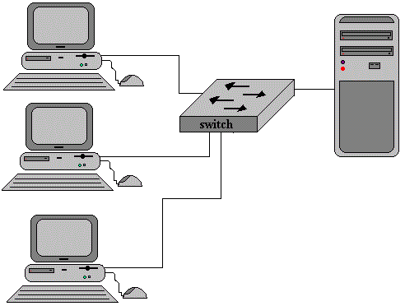

Ans: (Sample)

1. Network Topology (Screen Shot)
2. IP Address Configuration of PCs (Configuration Steps & Screen Shots)
3. Use ping utility to check availability of end systems/host
4. Configure web server, DNS and create a sample html page on web server
5. Access web page from client PC using web browser on client desktop
6. Real Mode Simulation (Screen Shots)

**ANS**

The IP configuration is :

* In 1st case connect all the computers to the switch using copper straight through table.
* -Select pc1 go to -> desktop ->Ip configuration, -In ipv4 address put 192.168.23.1 , 59 being my roll no. Do same for all the pc’s just increase the last bit of IP address. In both case

The ping by server to 2nd PC

The real mode stimulation

Submitted By – Kumari Palak

3323